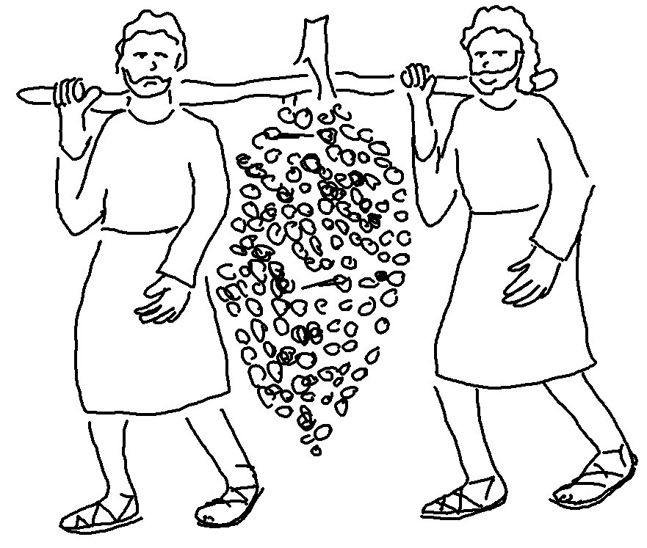
The Lord watches over all who _ _ _ _
_ _ _.
Psalms 145:20_{NLT}

